

**A**

**PROJECT REPORT**

**on**

**Home Automation System**

Submitted in partial fulfillment of the requirements for the award of the degree

of

MASTER OF COMPUTER APPLICATION

**BATCH (2017-2019)**



DR. A.P.J. ABDUL KALAM TECHNICAL UNIVERSITY

**Under the guidance of**

Mr. VIVEK AGARWAL

**Submitted to: Submitted by:**

**Vivek Agarwal** **Rohit Gupta**

(Assistant professor) (1716517929)

KANPUR INSTITUTE OF TECHNOLOGY, KANPUR

A-1, Near Chakeri Thana, UPSIDC Industrial Area,

Rooma, Kanpur, Uttar Pradesh 208001

Student Declaration

I hereby declare that the project work entitled “Home Automation System” submitted in partial fulfillment of the requirement for the award of degree of MCA and submitted to the “DR. A.P.J. ABDUL KALAM TECHNICAL UNIVERSITY” is authentic record of my own work carried out from 10 Feb 2018 to 10 May 2018.

This project report has not been submitted by me for any other degree/diploma of any university/institute.

Rohit Gupta

(1716517929)

**Acknowledgement**

First I would like to give my sincere thanks to **Dr.(Prof.) Brajesh Varshney, Director** of **“KANPUR INSTITUTE OF TECHNOLOGY, KANPUR”** for assisting me and imparting his valuable guidance to me to fulfill this aim of the project in the desired direction.

With great esteem and reverence, I wish to express my deep sense of gratitude to my project guide **Mr. VIVEK AGARWAL** for his valuable guidance and constant motivation. My sincere gratitude is expressed for his help, patronage and for going through the manuscript critically.

.

I am also very much thankful to **Prof. Sanjeev Shukla (MCA Co-ordinator),** **KANPUR INSTITUTE OF TECHNOLOGY, KANPUR**, who always readily listened to my problems and willingly tried to solve them which directly inculcated conceptual approach.

A special thanks to all faculty members for their kind co-operation and moral support without which the making of this project would have been impossible.

Finally, I would like to thanks my faculty members, Library & staff members, my friends and special thanks to my parents who are supporting for their co-operation to complete this project.

**DATE: Signature:**

**(………………………) (…….………………...)**

**KANPUR INSTITUTE OF TECHNOLOGY, KANPUR**

A-1, Near Chakeri Thana, UPSIDC Industrial Area,

Rooma, Kanpur, Uttar Pradesh 208001

**CERTIFICATE**

This is to certify that the Mini Project Report entitled

**Home Automation System**

Submitted in partial fulfillment of the requirement for the award of the degree of

**“MASTER OF COMPUTER APPLICATION”**

To DR. A.P.J. ABDUL KALAM TECHNICAL UNIVERSITY for the session 2017-2019 and this project report work carried out by

**Rohit Gupta**

Certify under my personal supervisor and guidance no part of this report has been submitted for the award of any other degree, Diploma, fellowship or other similar titles or prizes that the work has not been published in any scientific or popular journal or magazine.

**PROJECT CO-ORDINATOR GUIDED BY**

**Mr. Sanjeev Shukla Mr. VIVEK AGARWAL**

**PREFACE**

This project is an integral part of MCA program for the partial fulfilment of this course. Developer got the opportunity to undertake his project in “**KANPUR INSTITUTE OF TECHNOLOGY, KANPUR”** where project was assign tome was entitled “Home Automation System” Developer has done work on PYTHON. In this project developer have done his level best to explore as much as possible and have tried to give maximum possible view of respondents towards the programming.

Developers hopes this project is comprehensive and gives the realistic.

View of people towards “Home Automation System”

As such developer, herby his project for evolution, which gives and insight.

Over the current prevailing in PYTHON.

**KANPUR INSTITUTE OF TECHNOLOGY, KANPUR,**

**Master of Computer Application,**

**Rohit Gupta**

**Date Signature**

**(………………………) (………………………)**

**Home Automation System**

*A cheap and open-source alternative to control household appliances*

Table of contents

Contents

1. Introduction

2. Arduino

3. Bluetooth Module

4. Android Application

6. Working Explanation In PC

7. Some Picture of project

8. Future Work

**1. Introduction**

Today, technology has become an integrated part of people's lives. It has, and continues to influence many aspects of daily life and has allowed better social interaction, ease of transportation, the ability to indulge in entertainment and media and has helped in the development in medicine. The creation of many devices such as mobile phones and computers have caused many people to rely on technology to communicate with their friends, store information such as pictures, movies, documents, and music . The internet has become a common interface that many devices use in order to simplify the daily life of many people.

The Internet has given people the ability to search for information, store their own information in the cloud while also giving them better ways of managing information. From the time of its introduction, the amount of people that use mobile phones and the internet to communicate with other people has increased dramatically to become one of the major means of communication.

Smartphones have allowed people to connect to the internet without the need for a computer, while still offering the same functionality but through different means. With the introduction of better hardware and better software, smartphones have become powerful devices and have become an important part of people’s daily lives. A major aspect is how the smartphone is able to connect and communicate with other devices. For example, smartphones can be used as a mouse for a computer, or it can connect to the speakers of cars allowing consumers to play their own music. There are many applications of this sort.

A field that is recently gaining popularity is home automation which can also use smartphones as information or functionality hubs.

**2. Arduino**

Arduino is a single-board microcontroller board based on Atmel’s 8-bit microcontrollers [19] and is shown in figure 5. The hardware is open-source which means that the user is allowed to study and make changes to the hardware. All original design files are also available.

The standard Arduino board is the Arduino Uno [20]. It is based on Atmel’s ATmega328 microcontroller. The board has 14 digital input/output pins and 6 analog input pins. There are also other models of Arduino boards available with varying sizes, number of I/O pins and functionality [21]. Some of these are the Arduino Mega [22], which is bigger than the Uno and features 54 digital I/O pins and 16 analog input pins, and LilyPad Arduino [23], which is designed to be wearable and only has 9 I/O pins.

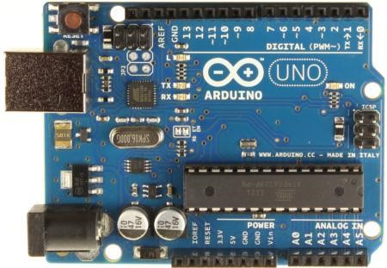

*Figure 5: The Arduino Uno board [P5]*

For more functionality one can attach add-on modules called “shields” [24] to some of the boards. Some of the functionality shields provide are motor controls, GPS, ethernet, Wi-Fi and LCD displays. The shields are connected to the I/O headers on the board and, depending on what pins are used, can often be stacked on top of each other [25].

The Arduino microcontroller is programmed in C/C++ either by using the Arduino IDE or by using a text editor and manually compiling and linking the source code. The IDE is open-source and is written in Java and is thus also cross-platform [26]. The IDE handles the compiling and linking of the source code and uploads the resulting hex file to the board where it will start running [27].

**3. Bluetooth Module:**

HC-05 Bluetooth module consists two things one is Bluetooth serial interface module and a Bluetooth adaptor. Bluetooth serial module is used for converting serial port to Bluetooth.

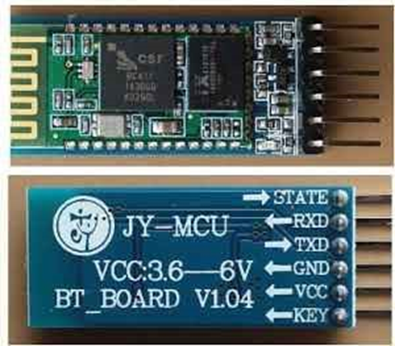

we can directly use the Bluetooth module after purchasing from market, because there is no need to change any setting of Bluetooth module. Default baud rate of new Bluetooth module is 9600 bps. You just need to connect rx and tx to controller or serial converter and give 5-volt dc regulated power supply to module.

Bluetooth module has two modes one is master mode and second one is slave mode. User can set either mode by using some AT commands. Even user can set module’s setting by using AT command. Here are some commands uses are given:

First of all, user need to enter AT mode with 38400 bps baud rate by pressing EN button at Bluetooth module or by giving HIGH level at EN pin. Note: all commands should end with \r\n (0x0d and 0x0a) or ENTER KEY from keyboard.

After it if you send AT to module then module will respond with OK

AT → Test Command

AT+ROLE=0 → Slave Mode select

AT+ROLE=1 → Master Mode select

AT+NAME=xyz → Set Bluetooth Name

AT+PSWD=xyz → Set Password

AT+UART=<value1>, <value2>, <value3> → set Baud rate

E.g. AT+UART=9600,0,0

**Pin Description of accelerometer:**

1. STATE → Open
2. Rx → Serial receiving pin
3. Tx → Serial transmitting pin
4. GND → ground
5. Vcc → +5volt dc
6. EN → to enter in AT mode

**4. Android Application**

In this project we have usedArduino uno R3 for controlling the whole process of this project. And a Bluetooth module is used for controlling the home appliances wirelessly. Home appliances will turned ON and OFF when user will touch button in the Bluetooth mobile app in Android mobile phone. To run this project, first we need to download Bluetooth app form Google play store. We can use any Bluetooth app that can send data using Bluetooth. Here are some apps name that can be used BUlB CONTROL ARUDNIO app.

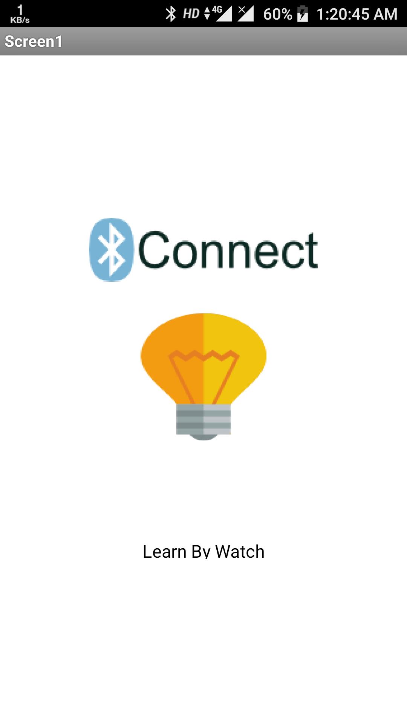

After installing the App, you need to open it and then search Bluetooth device and select HC-05 Bluetooth device. And then configure keys.

Here in this project we have used BUlB CONTROL ARUDNIO app.

|  |  |  |
| --- | --- | --- |
| **Button** | **Data** | **Operation** |
| Bulb On | 1 | Bulb Turned On |
| Bulb Off | 0 | Bulb Turned Off |

**5. Working Explanation**

**In PC**

**Code in Arduino IDE :-**

**char data = 0;**

**void setup()**

**{**

**Serial.begin(9600);**

**pinMode(13, OUTPUT);**

**}**

**void loop()**

**{**

**if(Serial.available() > 0)**

**{**

**data = Serial.read();**

**Serial.print(data);**

**if(data == '1')**

**digitalWrite(13, HIGH);**

**else if(data == '0')**

**digitalWrite(13, LOW);**

**}**

**}**

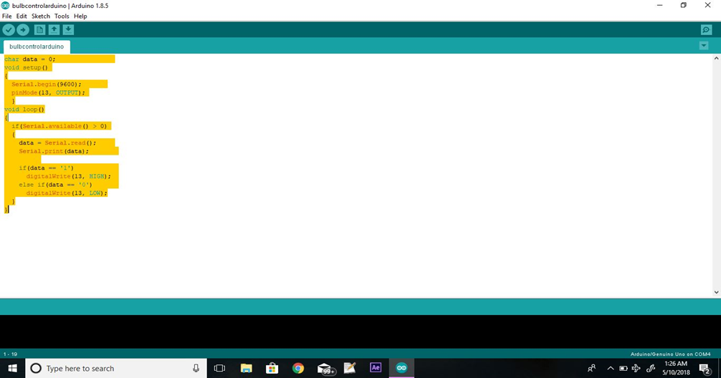

**7. Some Picture of project**

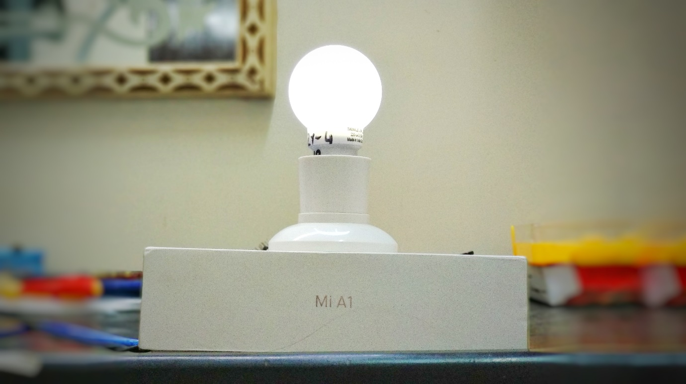

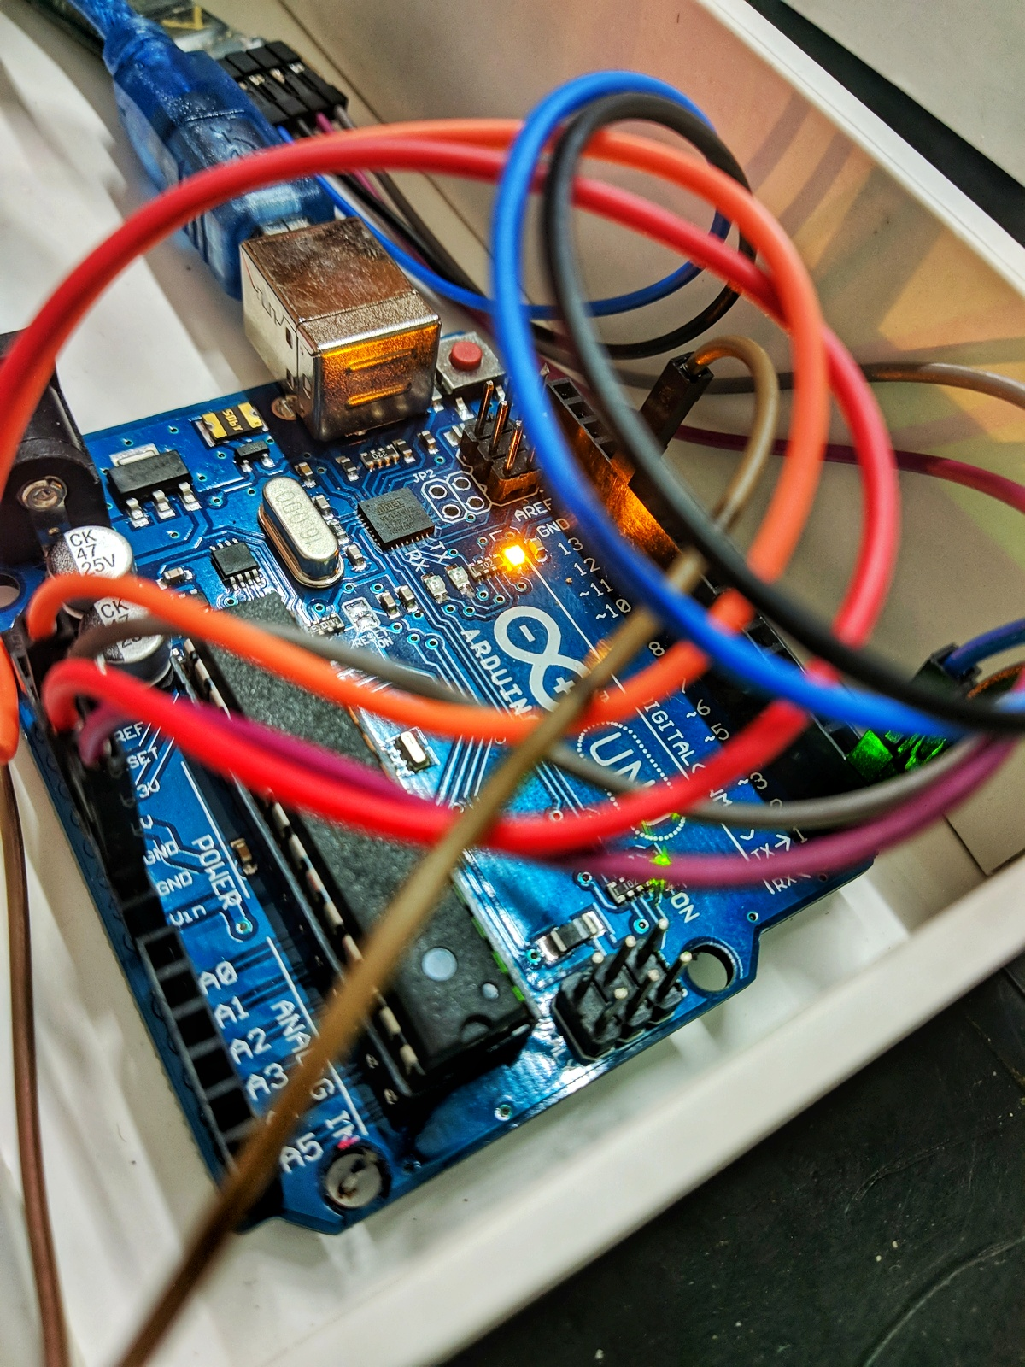

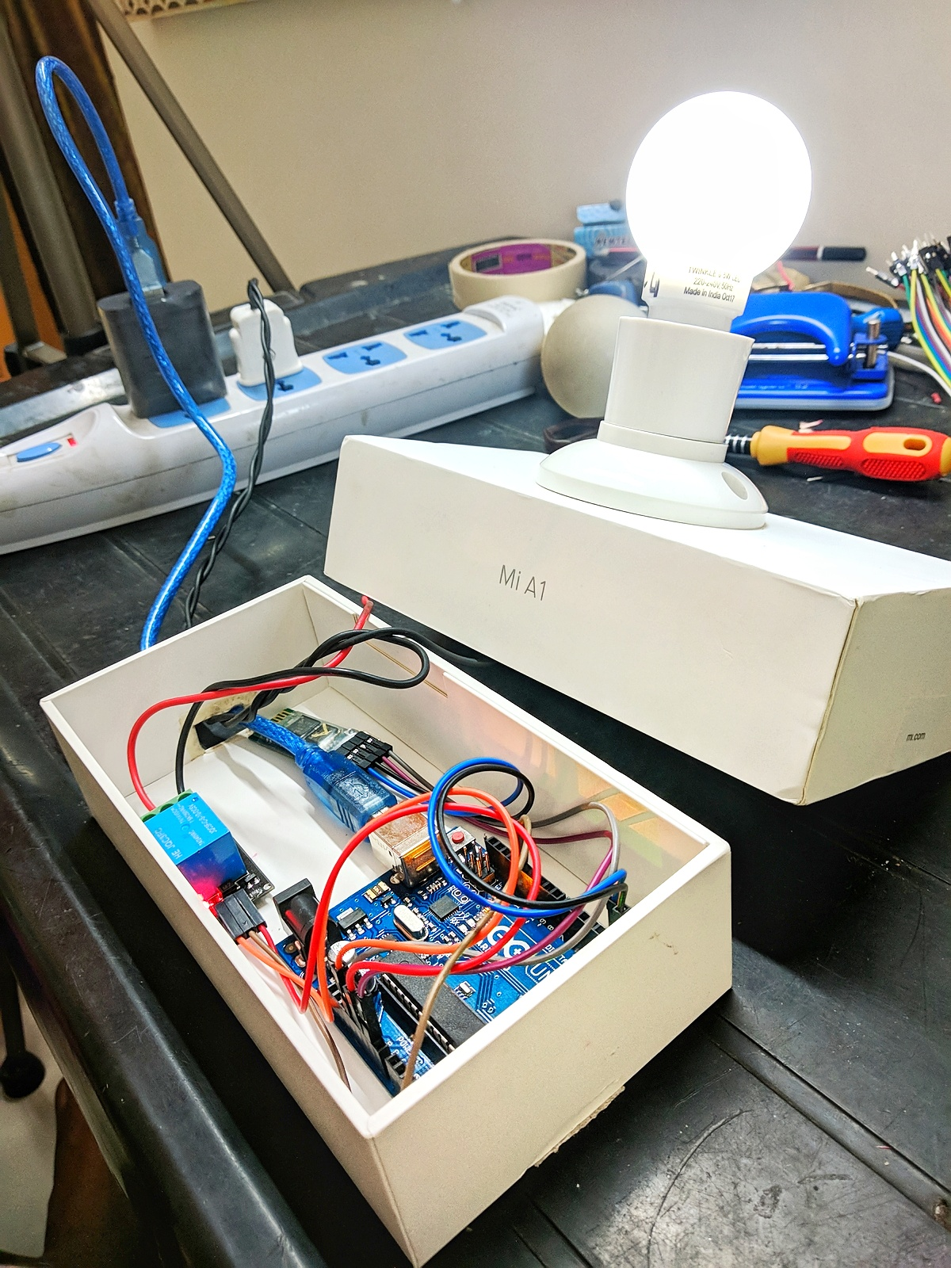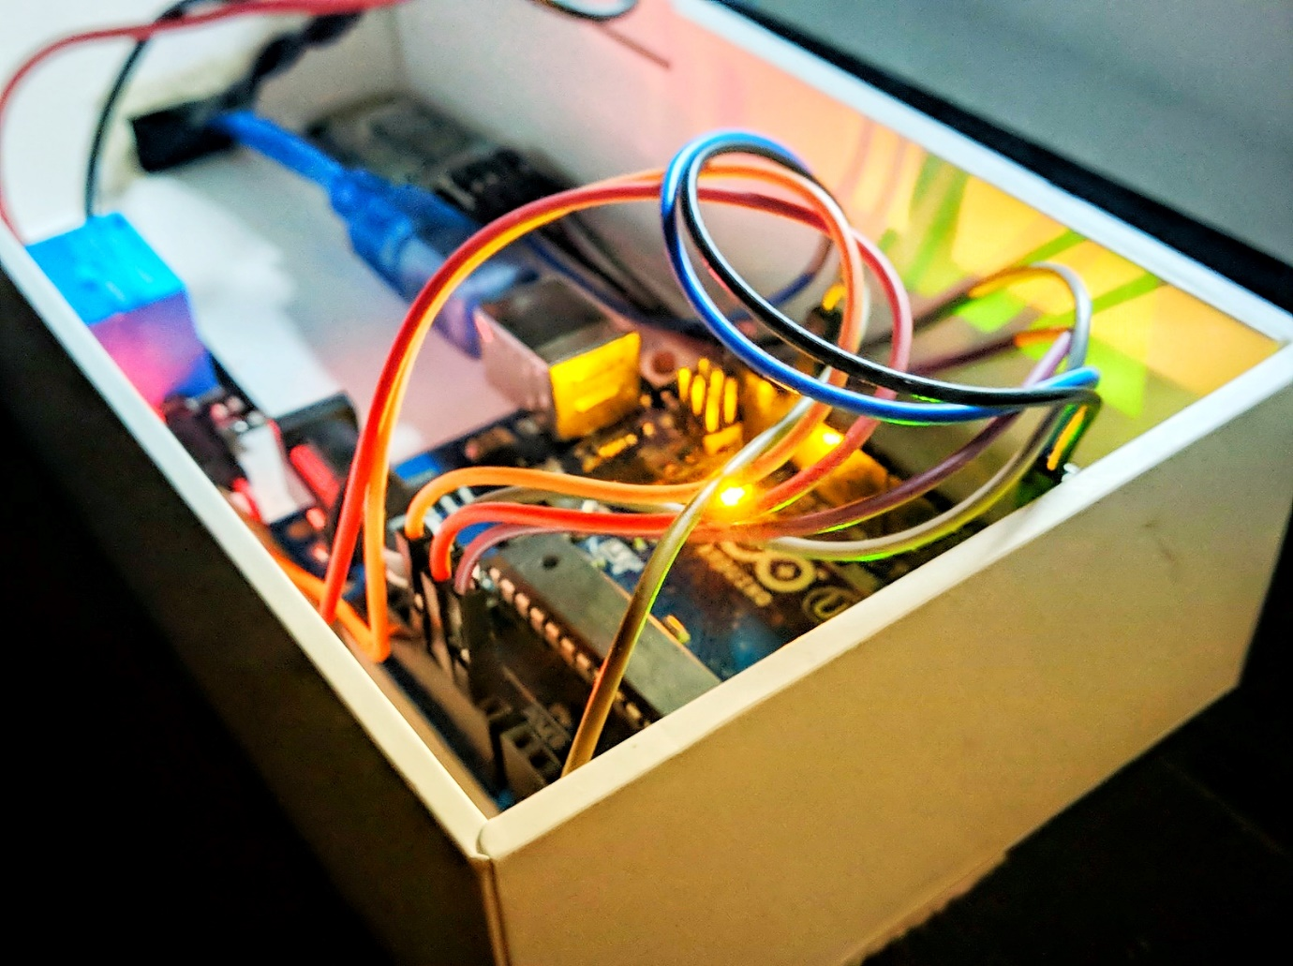

8. Future Work

To ensure that the prototype created during this project can achieve its maximum potential, there are a number of improvements and changes that can be implemented. Also, the problems encountered throughout this project should be addressed.

Foremost, the most prominent would be the Raspberry Pi working as a central unit connecting the consumer to devices in his/her home. Therefore, looking into a two-way communication between the Raspberry Pi and the device. For the Raspberry Pi, that would be the use of Zwave putting into account the low price of the attachment module and its compatibility with home appliances allowing the control of them wirelessly. This solution also discards the power management problem since the Raspberry Pi would then be powered from an electricity outlet.

A problem which occurred was the locking detection when manually locking/unlocking the door. The solution to this problem was the use of a sensor but that was not possible, and is explained in section 5.1.5. Therefore, anyone attempting to continue this project should spend some time researching the use of a wireless sensor sending information back to the Raspberry Pi directly. This would require choosing a very small microprocessor using a two-way transceiver powered by a battery capable of powering these devices for a long period of time.

The prototype can offer more diverse ways of locking/unlocking the door by using other technologies. For example, Bluetooth LE can be used such that the door unlocks when the consumer is close to the door. The door can be unlocked through voice recognition, or using a door pinhole camera with facial recognition abilities. The phone application could use GPS or detect when the user connects or disconnects from the home Wi-Fi network to unlock or lock the door.

Some of the proposed features of the software could not be implemented in time. One of these features was having guest accounts with a limited time access to a lock and a user interface in the application to manage this. Another feature was logging of all user actions on the server side and a way to display it to the user either in the app or via a website. The application also needs to have a way to add a device to the users list of devices and owners of locks need to be able to manage who else has access to their device.